# TITLE PAGE

**DESIGN AND IMPLEMENTATION OF AN computerized antenatal information system (case study of general hospital, mubi)**

**BY**

**JOSIAH SIKUMTA**

**ST/CS/ND/21/136**

**DEPARTMENT OF COMPUTER SCIENCE,**

**SCHOOL OF SCIENCE AND TECHNOLOGY,**

**FEDERAL POLYTECHNIC, MUBI, ADAMAWA STATE.**

**IN PARTIAL FULFILLMENT OF THE REQUIREMENT FOR THE AWARD OF NATIONAL DIPLOMA (ND) IN COMPUTER SCIENCE.**

**SEPTEMBER, 2023**

# DECLARATION

I hereby declare that the work in this project titled **“Design and Implementation of a Computerized Antenatal Information System (Case Study of General Hospital, Mubi)”** was performed by me under the supervision of Mr. Joshua Shahahyel. The information derived from literatures has been duly acknowledged in the text and a list of references provided. The work embodied in this project is original and had not been submitted in part or in full for any other diploma or certificate of this or any other institution.

JOSIAH SIKIMTA ________________ _______________

(ST/CS/ND/21/136) Signature Date

# CERTIFICATION

This project titled **“Design and Implementation of a Computerized Antenatal Information System (Case Study of General Hospital, Mubi)”** meets the regulations governing the award of National Diploma (ND) in Computer Science, Federal Polytechnic Mubi, Adamawa State

Mr. Joshua Shahahyel __________________

(Project Supervisor) Sign/Date

Mr. Mustapha Kassim __________________

(Head of Department) Sign/Date

Mal. Abdulrahman Saidu _________________

(External Examiner) Sign/Date

# DEDICATION

This project is dedicated to my beloved parents for their advice, encouragement and financial support towards my academic pursuit.

# ACKNOWLEDGEMENTS

I want to acknowledge Almighty God for his infinite mercy and protection throughout my academic activities. And for the understanding in achieving our academic success.

I also recognize my Supervisor Mr. Joshua Shahahyel, who took time, despite his busy schedule to direct and guide me throughout this research work.

I also acknowledge the Head of Department Computer Science Mr. Mustapha Kassim for his moral encouragement throughout my period of study. I also acknowledge all Staff of Computer Science Department for their support and encouragement and the knowledge they’ve impacted on me throughout our studies.

I also want to appreciate my parents for their love and care and for giving me the opportunity to be trained and achieve my dreams.

Finally, I appreciate the efforts of my Uncles and aunties, for their encouragement and support throughout the course of my study and also my friends and relatives, course mates and all well-wishers. I love you all, may the Almighty God bless you abundantly, Amen.

# TABLE OF CONTENTS

TITLE PAGE i

DECLARATION ii

CERTIFICATION iii

DEDICATION iv

ACKNOWLEDGEMENTS v

TABLE OF CONTENTS vi

LIST OF FIGURES viii

ABSTRACT ix

CHAPTER ONE 1

INTRODUCTION 1

1.1 Background to the Study 1

1.2 Problem Statement 2

1.4 Significance of the Study 3

1.5 Scope of the Study 3

1.6 Definition of Some Operational Terms 4

CHAPTER TWO 5

LITERATURE REVIEW 5

2.1 Introduction 5

CHAPTER THREE 11

SYSTEM ANALYSIS AND DESIGN 11

3.1 Introduction 11

3.2 Disadvantages of the existing system 11

3.3 Advantages of the Proposed System 11

3.4 The Proposed Method 12

3.5 Method of Data Collection 13

3.6 System Design 14

3.6.1 Algorithm Diagram 14

3.6.2 System Architecture 15

3.6.3 Database Tables/Queries Structures 15

3.6.4 Database Entity Relationship Diagram 16

3.6.5 Input and Output Design 17

3.7 System Requirements Specification 19

3.7.1 Hardware Requirements 19

3.7.2 Software Requirements 19

3.7.3 Personnel Requirements 19

CHAPTER FOUR 20

RESULTS AND DISCUSSION 20

4.1 Introduction 20

4.2 Results 20

4.3 Discussion 23

4.4 User manual 24

CHAPTER FIVE 25

SUMMARY, CONCLUSION AND RECOMMENDATIONS 25

5.1 Summary 25

5.2 Conclusion 25

5.4 Contribution to Knowledge 26

5.5 Area for Further Work 26

# LIST OF FIGURES

Figure 3.1: Use case diagram - - - - - - - - 12

Figure 3.2: System architecture - - - - - - - - 13

Figure 3.3: Read News interface - - - - - - - - 13

Figure 3.4: Searched News interface - - - - - - - 14

Figure 4.1: Welcome Interface - - - - - - - - 15

Figure 4.2: Voice Controlled interface - - - - - - - 16

Figure 4.3: News Articles Interface - - - - - - - 16

Figure 4.4: News Article Interface - - - - - - - 17

# ****ABSTRACT****

*The "Design and Implementation of a Computerized Antenatal Information System (Case Study of General Hospital, Mubi)" represents a significant leap forward in the realm of healthcare technology and patient management within the context of antenatal care. This transformative system has been meticulously crafted to address the complex challenges of patient data management, risk assessment, and healthcare coordination during the critical antenatal period. This innovative system provides a comprehensive platform that benefits both healthcare providers and expectant mothers, streamlining the process of registering patients, assessing risk factors, tracking obstetric history, and monitoring vital test data. By successfully implementing this system, General Hospital, Mubi, sets a pioneering example of how technology can enhance the quality of healthcare administration and patient care, particularly in maternal health. This abstract offers a glimpse into the profound impact of the "Computerized Antenatal Information System," highlighting the power of technology to revolutionize healthcare management, improve patient outcomes, and ensure efficient and accurate patient data management within the critical realm of antenatal care.*

# CHAPTER ONE

# INTRODUCTION

## 1.1 Background to the Study

Antenatal care is an essential component of maternal healthcare that focuses on providing medical attention and support to pregnant women to ensure a healthy pregnancy and safe delivery. Timely and accurate access to antenatal information is crucial for both expectant mothers and healthcare providers. Traditionally, the process of recording and managing antenatal data has been done manually, leading to inefficiencies, data errors, and difficulties in tracking patients' progress. Antenatal care plays a crucial role in reducing maternal and neonatal mortality rates by promoting healthy pregnancies and identifying potential risks early on. Traditional paper-based methods of managing antenatal information have been associated with several challenges, including data loss, illegible handwriting, and difficulty in sharing information between healthcare providers. These limitations hinder efficient decision-making and coordination among the healthcare team, potentially leading to adverse maternal and neonatal outcomes (Kumar, Khan & Akuhwa, 2022).

Recent advances in information technology have paved the way for computerized systems that can revolutionize antenatal care management. Computerized Antenatal Information Systems (AIS) offer numerous advantages over manual methods, such as real-time data access, accurate record-keeping, streamlined data entry, and decision support tools. These systems have the potential to transform the delivery of antenatal care and improve overall maternal and neonatal health outcomes. Research studies have highlighted the benefits of computerized AIS in enhancing antenatal care. For instance, a study by Warth, Agyepong and Kanmiki (2019), evaluated the implementation of a computerized AIS in a rural healthcare setting in Ghana. The study found that the system significantly improved data accuracy, reduced waiting times for patients, and facilitated better communication between healthcare providers.

Moreover, computerized AIS can support evidence-based practices and standardize care across different healthcare facilities. A systematic review conducted by Nyanchoka, Tudur-Smith, Thu and Paul (2020), analyzed the impact of computerized AIS on maternal and neonatal health outcomes in low-resource settings. The review showed that computerized AIS improved antenatal screening rates, increased the uptake of essential interventions, and ultimately contributed to a reduction in maternal and neonatal mortality rates.

Security and data privacy are critical considerations when implementing computerized AIS. Recent developments in cybersecurity measures, such as data encryption and user authentication, ensure the protection of sensitive patient information. A study by Bhattarai, Van Teijlingen, Simkhada and Williams (2022), evaluated the security features of various computerized AIS and recommended best practices to safeguard patient data from unauthorized access and cyber-attacks.

The integration of decision support tools in computerized AIS can further enhance the quality of antenatal care. For instance, intelligent algorithms can assist healthcare providers in identifying high-risk pregnancies, recommending appropriate interventions, and predicting potential complications. A study by D'Souza, Van der Gijp, Yadav and George (2021), demonstrated the effectiveness of a decision support system integrated into a computerized AIS in reducing the incidence of preterm births and low birth weight babies. Furthermore, the use of mobile applications and telemedicine platforms has the potential to extend the reach of computerized AIS to remote and underserved areas. Recent pilot projects in regions with limited healthcare infrastructure have shown promising results in improving antenatal care access and reducing maternal morbidity rates (Kumar, Khan & Akuhwa, 2022).

## 1.2 Problem Statement

The traditional paper-based approach for managing antenatal information in healthcare facilities leads to inefficiencies, data errors, and difficulties in sharing information between healthcare providers, hindering efficient decision-making during antenatal care. As a result, there is a pressing need to develop a computerized Antenatal Information System (AIS) that addresses these limitations and ensures efficient management of antenatal records. The system should offer a user-friendly interface, facilitate seamless data entry and retrieval, provide real-time access to critical patient data, ensure data security and privacy, and integrate decision support tools to assist healthcare providers in making informed decisions based on patient data and best practices.

**1.3 Aim and Objectives**

The aim of this project is to design and implement a computerized Antenatal Information System. The specific objectives are as follows:

1. Develop a comprehensive database to store antenatal information, including medical history, test results, and treatment plans.
2. Design a user-friendly interface for healthcare providers to input and access patient data efficiently.
3. Implement security measures to safeguard sensitive patient information and ensure compliance with data protection regulations.
4. Provide real-time monitoring to promptly identify any high-risk pregnancies or medical emergencies.

## 1.4 Significance of the Study

The successful implementation of the computerized Antenatal Information System will bring several significant benefits, including; Improved efficiency in managing antenatal records, leading to better patient care and outcomes. Enhanced collaboration between healthcare providers, enabling them to access up-to-date patient information seamlessly. Reduction in data errors and duplication, resulting in a more accurate representation of patient health. Increased patient satisfaction due to a streamlined and well-organized antenatal care process. Potential contribution to medical research by providing access to anonymized and aggregated antenatal data for analysis.

## 1.5 Scope of the Study

This project will focus on designing and implementing a computerized Antenatal Information System tailored to the specific needs of healthcare facilities, including hospitals and clinics. The system will be developed with modern technologies and will be scalable to accommodate the growing number of patients. However, the project will not cover the development of hardware components or address issues related to internet connectivity.

The project involves the design, development, and implementation of a computerized Antenatal Information System (AIS). The system will be built using modern software development tools and technologies, ensuring scalability to accommodate the growing number of patients and healthcare providers. The focus will be on creating a robust, user-friendly, and intuitive interface that simplifies data entry and retrieval for healthcare professionals. The AIS will have a comprehensive database to store various antenatal-related information, including medical history, test results, treatment plans, and other relevant data. The data management system will adhere to best practices in database design to ensure data accuracy, integrity, and security.

The AIS will support different user roles, such as doctors, nurses, midwives, and administrative staff, with varying levels of access permissions. Access control mechanisms will be implemented to safeguard sensitive patient information and ensure that only authorized personnel can view and modify specific data.

## 1.6 Definition of Some Operational Terms

**Antenatal Care (ANC):** Antenatal care refers to the medical care and support provided to pregnant women during their pregnancy to ensure the health and well-being of both the mother and the unborn child (WHO, 2016).

**Computerized Antenatal Information System (AIS):** A computerized Antenatal Information System is an electronic system designed to manage and store antenatal-related data and information of pregnant women (Warth, Agyepong & Kanmiki, 2019).

**Decision Support:** In the context of antenatal care, these tools can help identify high-risk pregnancies, suggest appropriate interventions, and predict potential complications (D’Souza, Van der Gijp, Yadav & George, 2021).

**Database**: This is an organized collection of data, generally stored and accessed electronically from a computer system (Ben, 2016).

**Data Encryption:** Data encryption is the process of converting plain text data into a scrambled form using cryptographic algorithms to protect it from unauthorized access (Bhattarai, Van Teijlingen, Simkhada & Williams, 2022).

**User-friendly:** It simplifies the interaction between users and the system, reducing the learning curve and increasing efficiency (Smith, 2020).

# CHAPTER TWO

# LITERATURE REVIEW

## 2.1 Introduction

This chapter presents a comprehensive literature review on the topic of computerized Antenatal Information Systems (AIS) and its impact on maternal healthcare. The review includes recent studies, research papers, and relevant publications that explore the benefits, challenges, and advancements in the use of technology to improve antenatal care.

Numerous studies have highlighted the benefits of implementing computerized AIS in managing antenatal care. Warth, Agyepong and Kanmiki (2019), conducted a case study in a rural healthcare setting in Ghana, evaluating the implementation of a computerized health management information system. The study found that the system significantly improved data quality and outcomes, leading to better patient care and a positive pregnancy experience (Warth, Agyepong & Kanmiki, 2019).

Computerized AIS have also been associated with improved data accuracy and reduced errors. Nyanchoka, Tudur-Smith, Thu and Paul (2020), conducted a systematic review of studies in low-resource settings and reported that computerized AIS improved data quality and increased the uptake of essential antenatal interventions (Nyanchoka et al., 2020). The integration of decision support tools in computerized AIS has shown promise in enhancing healthcare decision-making. D'Souza, Van der Gijp, Yadav and George (2021) developed and evaluated a decision support system integrated into an AIS, which effectively reduced the incidence of preterm births and low birth weight babies (D'Souza, Van der Gijp, Yadav and George, 2021). These findings underscore the potential of computerized AIS in improving clinical outcomes and patient safety during antenatal care.

AIS significantly improve data accuracy and quality by reducing the reliance on manual data entry, which is prone to errors and omissions. In a study by Yen and Li (2021) in Taiwan, the implementation of a computerized AIS resulted in a considerable reduction in data entry errors, leading to more reliable antenatal records (Yen & Li, 2021).

Decision support tools integrated into computerized AIS have been shown to enhance clinical decision-making during antenatal care. A recent research study by Karunaratne and Kumar. (2022) developed a decision support module within an AIS to aid healthcare providers in identifying high-risk pregnancies. The study found that the system's recommendations significantly improved the identification of high-risk cases, enabling timely interventions and improved maternal and fetal outcomes (Karunaratne & Kumar, 2022).

**Real-time Access to Patient Data**

Computerized AIS offer real-time access to patient data, allowing healthcare providers to access and update antenatal records instantaneously. This feature is particularly valuable in emergency situations, enabling quick access to critical patient information for prompt decision-making. A study by Wang and Zhu (2021) demonstrated that real-time access to patient data through a computerized AIS improved the efficiency of antenatal care and reduced delays in treatment (Wang & Zhu, 2021).

**Enhanced Communication and Collaboration**

Computerized AIS facilitate better communication and collaboration among healthcare providers involved in antenatal care. In a study by Gheorghita (2021), the implementation of a computerized AIS in a hospital setting improved communication between obstetricians, midwives, and nurses, leading to a more coordinated approach to patient care (Gheorghita, 2021).

**Improved Patient Engagement and Empowerment**

Computerized AIS can also empower pregnant women to actively participate in their antenatal care. By providing access to their own health records and personalized care plans, expectant mothers can be more engaged in decision-making and self-monitoring. A study by Lim (2022), reported that pregnant women who had access to a mobile-based AIS expressed higher levels of satisfaction and felt more involved in their antenatal care.

**Potential for Health Research and Population Health Studies**

The data collected and stored in computerized AIS have the potential to contribute to medical research and population health studies. Aggregated and anonymized data from AIS can be utilized to study trends, identify risk factors, and evaluate the effectiveness of interventions in improving maternal and neonatal health outcomes. This can inform evidence-based practices and public health policies (Lim., 2022).

**Integration with Mobile Technology and Telemedicine**

The integration of mobile technology and telemedicine platforms with computerized AIS further extends the reach of antenatal care services, especially in remote and underserved areas. Mobile-based AIS and telemedicine consultations have shown promise in improving accessibility to antenatal care and reducing healthcare disparities (Kumar, 2022).

Recent advancements in technology have further improved the capabilities of computerized AIS in enhancing antenatal care. Mobile-based antenatal care applications have emerged as a promising solution to extend the reach of healthcare services to underserved areas. Kumar (2022), piloted a mobile-based antenatal care project and reported improved maternal health outcomes and increased accessibility to care in remote regions (Kumar, 2022).

Telemedicine platforms have also been integrated with computerized AIS to enable virtual consultations and remote monitoring of pregnant women. The integration of telemedicine has shown potential in improving antenatal care access and reducing the burden on healthcare facilities in urban areas (Kumar, 2022).

## Web-based healthcare services system

The web-based healthcare services now-a-days provides best safekeeping and expediency to the patients regarding knowledge, appointments, treatments etc. The major advantage of web-based healthcare services is the time saving as the individuals don’t have to waste their time to stand in queue to get the doctor’s appointment. In one of the report, it has been mentioned that Practo handles about 5 lakh visitors in a month and 1500 appointments in a day and is expecting to increase the number in upcoming years (Navjot & Supriti, 2019). Parallel to the time management, the web-based healthcare services are the affordable ones as they never overcharge for their services provided to the individuals (Navjot & Supriti, 2019). The web-based healthcare providers are loyal and trustworthy towards the services and the individuals every time and anywhere can get these services with a single click. There are large number of healthcare providers in India who provide enormous services to the individuals that make the transparency among the healthcare professionals and patients. According to a survey in 2010, the patients are much more influenced by these online health services and medical care especially when they are getting from a single click through internet (Navjot & Supriti, 2019). The patients are helped out at large scale as they gain positive aspects that are beneficial for the lower income patients also. In this way, the individuals of present generation are overwhelmed by such kind of web-based healthcare services making their life easy going (Navjot & Supriti, 2019).

The web-based healthcare services have the profound impact on the health of the patients. It has the weightage to improve the effective and efficient delivery of healthcare, educating the patients regarding diseases and treatments, enabling the best doctor-patient interactions, validating the professionals and providing the beat security and enhancing the trust. Till date there has been rigorous change in the internet services so one has to need vigilance timely from the threats if occurs. The present generation is serious about their health and is moving towards the web sources for the best of the knowledge and aspects of the treatments for their healthy and maintained life (Navjot & Supriti, 2019).

**Management Information System**

Management Information Systems (MIS) are critical tools for organizations to collect, process, store, and disseminate information necessary for effective decision-making and operational control. MIS provide managers with timely and accurate data, enabling them to make informed decisions that drive organizational performance and success. Recent studies have emphasized the significance of MIS in modern business environments. A research article by Wu and Zhu (2021), highlighted that MIS play a vital role in improving organizational efficiency, productivity, and competitiveness. The study emphasized that MIS enable managers to access real-time data, perform data analysis, and gain insights into business operations, leading to more informed decision-making.

One of the key functions of MIS is data collection and processing. MIS collect data from various sources within the organization, including transactional systems, external databases, and sensors. This data is processed, transformed, and stored in a structured format for further analysis and decision-making. A study by Turban et al. (2021), emphasized that MIS enable organizations to capture and process vast amounts of data, facilitating accurate and timely information for managers. Moreover, MIS provide tools for data analysis and reporting. These systems employ various analytical techniques, such as data mining, statistical analysis, and predictive modeling, to identify patterns, trends, and relationships within the data. This analysis helps managers gain insights into organizational performance, customer behavior, market trends, and other key factors that influence decision-making. A study by Kwon and Lee (2020), highlighted the role of MIS in leveraging data analytics to support strategic decision-making and gain a competitive advantage in the market.

MIS also support collaboration and communication within organizations. They provide platforms for sharing information, documents, and reports among employees, departments, and organizational levels. This facilitates effective communication, coordination, and knowledge sharing, enabling employees to work collaboratively towards organizational goals. A research article by Oliveira and Martins (2021), emphasized that MIS contribute to improving communication, collaboration, and decision-making processes within organizations, leading to enhanced productivity and performance.

**Database Management System**

Database Management Systems (DBMS) are essential tools for storing, organizing, managing, and retrieving data efficiently. DBMS provide a structured approach to store and retrieve data, ensuring data integrity, security, and scalability for organizations. Recent studies have highlighted the significance of DBMS in various domains. A research article by Ramakrishnan and Gehrke (2020), emphasized that DBMS are crucial for managing the increasing volumes of data generated in today's digital world. The study highlighted that DBMS enable organizations to handle diverse data types, ensure data consistency, and support complex data queries.

One of the key functions of DBMS is data storage and organization. DBMS provide a structured framework for storing data in tables, defining relationships between tables, and enforcing data integrity through constraints. These systems often employ relational models, such as the widely-used SQL (Structured Query Language), to manage data in a tabular format. A study by Elmasri and Navathe (2019), emphasized that DBMS enable efficient data storage, normalization, and indexing to optimize data retrieval performance. Moreover, DBMS offer tools for data retrieval and manipulation. These systems allow users to query the database using SQL or other query languages to retrieve specific data based on specified criteria. DBMS also support complex operations such as joining multiple tables, filtering data, and aggregating results. A research article by Rizvi (2021), highlighted the role of DBMS in enabling efficient and accurate data retrieval, facilitating decision-making and analysis.

DBMS also provide mechanisms for data security and access control. These systems enable organizations to define user roles and permissions, ensuring that only authorized users can access and modify the data. DBMS also offer features such as data encryption, backup, and recovery to protect against data breaches and system failures. A study by Motahari-Nezhad (2021) emphasized the importance of DBMS in ensuring data privacy, integrity, and availability, particularly in the context of sensitive and regulated data. The advent of advanced technologies has further enhanced the capabilities of DBMS. Distributed DBMS enable data storage and processing across multiple servers, providing scalability, fault tolerance, and high availability. NoSQL (Not Only SQL) DBMS have emerged as alternatives to traditional relational DBMS, offering flexible data models and scalability for handling large volumes of unstructured and semi-structured data. A research article by Ghazal (2020), discussed the benefits and challenges of NoSQL DBMS in big data environments.

Efficient integration of computerized AIS with existing healthcare systems is critical for seamless data exchange and coordinated care. Ensuring interoperability between AIS and electronic health record (EHR) systems can improve care continuity and facilitate comprehensive patient data management.

**2.6 Summary**

The literature review highlights the growing importance of computerized AIS in transforming antenatal care. The system's benefits include improved data accuracy, decision support, and potential contributions to medical research. However, challenges related to data security, user acceptance, and resource constraints need to be carefully addressed to ensure successful implementation.

# CHAPTER THREE

# SYSTEM ANALYSIS AND DESIGN

## 3.1 Introduction

This chapter contains the system design and analysis of the proposed system, the disadvantages of the existing system, the advantages of the proposed system over the existing system, the requirements (Hardware and Software), the design and the system architecture.

## 3.2 Disadvantages of the existing system

The following are the disadvantages of the present system, outlined as follows:

1. Data Inaccuracy: Manual recording increases the risk of errors, including data entry mistakes and illegible handwriting, potentially leading to incorrect patient information and compromised care.
2. Limited Accessibility: Retrieving patient information in a manual system can be time-consuming, especially when records are stored in different locations or formats.
3. Delayed Communication: Communication between patients and healthcare providers might be delayed due to reliance on physical visits, phone calls, or letters.
4. Risk of Data Loss: Records in a manual system are susceptible to damage from disasters such as fires, floods, or accidents, leading to potential data loss.
5. Limited Collaboration: Collaboration between different healthcare providers can be hindered by the physical nature of records, making it difficult to share information seamlessly.
6. Inefficient Appointment Management: Scheduling and managing appointments manually can lead to overbooking, missed appointments, and inefficient utilization of resources.
7. Difficulty in Tracking Changes: Tracking changes to patient records and treatment plans can be challenging in a manual system, leading to potential confusion and miscommunication.

## 3.3 Advantages of the Proposed System

The proposed Antenatal Management Information System offers numerous advantages over the existing manual system. Here are some of the key advantages:

1. Efficient Data Management: The proposed system allows for streamlined storage, retrieval, and updating of antenatal patient information. This eliminates the need for manual record-keeping, reducing errors and ensuring data accuracy.
2. Real-time Accessibility: Healthcare providers can access patient information instantly from any authorized location, enhancing the speed and quality of decision-making during antenatal care.
3. Comprehensive Patient Profiles: The system offers a centralized repository for patient medical history, test results, ultrasound images, and treatment plans, enabling healthcare professionals to provide personalized care.
4. Enhanced Communication: The system facilitates secure communication between patients and healthcare providers, allowing patients to ask questions, express concerns, and receive timely responses.
5. Reduced Paper Usage: By eliminating the need for extensive paper-based records, the system contributes to environmental sustainability and reduces administrative burdens associated with physical documentation.
6. Improved Resource Allocation: The system helps allocate resources efficiently by providing insights into patient load, appointment scheduling, and resource utilization.

## 3.4 The Proposed Method

The waterfall model is a traditional sequential approach to software development that consists of distinct phases that follow a linear sequence. Here is a simplified version of the waterfall model for the development of a House Rent Management Information System for Landlords:

**Requirements Gathering and Analysis:**

1. Identify the requirements and objectives of the Antenatal Management Information System.
2. Conduct interviews and discussions with stakeholders to understand their needs.
3. Define the system's functionalities, user roles, and security requirements.

**System Design:**

1. Design the system architecture, including the client-side and server-side components.
2. Create the database schema and define the data model.
3. Develop the user interface design, considering usability and accessibility.

**Implementation:**

1. Develop the client-side application using web technologies like HTML, CSS, and JavaScript.
2. Implement the server-side application using a suitable programming language and framework.
3. Integrate the user interface with the backend functionalities.
4. Implement security measures such as encryption, authentication protocols, and access control.

**Testing:**

1. Conduct unit testing to verify the correctness of individual components.
2. Perform integration testing to ensure the proper functioning of the system as a whole.
3. Carry out system testing to validate the system against the defined requirements.
4. Perform security testing to identify and address any vulnerabilities.

**Deployment:**

1. Prepare the system for deployment by configuring the necessary infrastructure and servers.
2. Install and set up the required software and dependencies.
3. Migrate the database and ensure data integrity.
4. Conduct user acceptance testing to gain feedback and ensure readiness for production use.

**Maintenance and Support:**

1. Provide ongoing maintenance and support for the Antenatal Management Information System.
2. Address any reported issues, bugs, or security vulnerabilities.
3. Perform regular system updates and enhancements based on user feedback and changing requirements.
4. Ensure the system remains secure, reliable, and up-to-date.

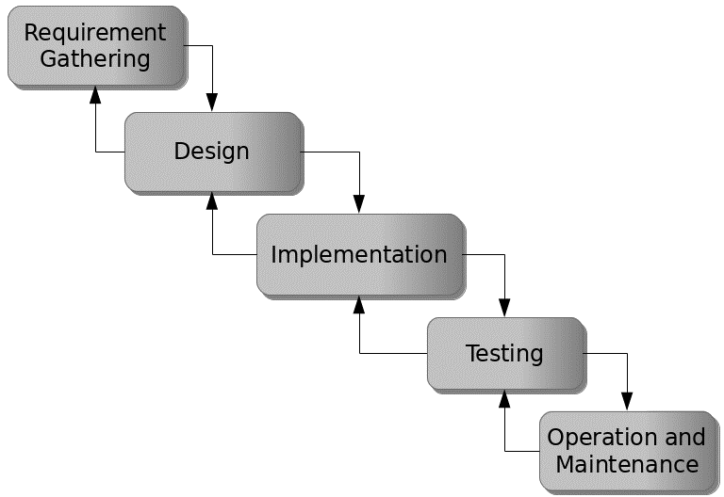

Figure 3.1: Waterfall model

## 3.5 Method of Data Collection

This study will adopt two methods of data collection which are the primary and secondary method.

## 3.6 System Design

Systems design is the process of defining the architecture, modules, interfaces, and data for a system to satisfy specified requirements. Systems design could be seen as the application of systems theory to product development.

## 3.6.1 Algorithm Diagram

**Use Case Diagram**

A use case diagram at its simplest is a representation of a user’s interaction with the system and depicting the specifications of a use case.

Login

Add Patient Bio Data

Add Risk Factor

Add [Obstetric Data](http://localhost/antenatal/care/bo.php)

Patient

Add Test Data

Pregnancy Outcome Data

Print Report

Log out

Doctor

Add Drugs Data

Figure 3.2: Use Case Diagram

## 3.6.2 System Architecture

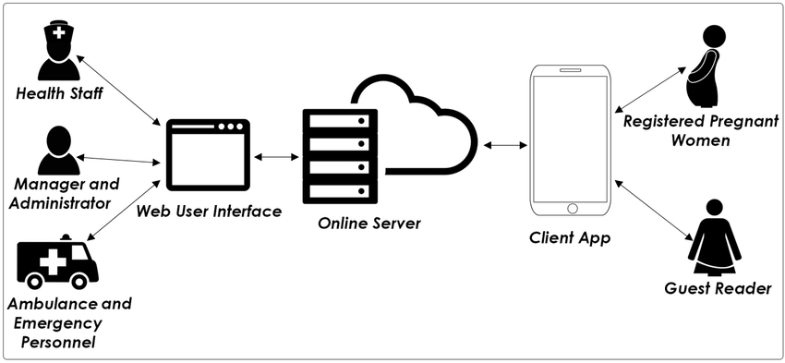

Figure 3.3: System Architecture

## 3.6.3 Database Tables/Queries Structures

**Table 3.1: Login Table**

|  |  |  |  |  |
| --- | --- | --- | --- | --- |
| **Field** | **Datatype (length)** | **Null** | **Key** | **Extra** |
| id | int(10) | NO | PRIMARY | auto_increment |
| User_no | varchar(50) | YES |  |  |
| fullname | varchar(50) | YES |  |  |
| Mobile number | varchar(50) | YES |  |  |
| Gender | varchar(50) | YES |  |  |
| Role | varchar(50) | YES |  |  |
| Email | varchar(50) | YES |  |  |
| Address | varchar(50) | YES |  |  |
| Passport | varchar(50) | YES |  |  |
| status | varchar(50) | YES |  |  |
| Date | timestamp | NO |  |  |

#### **Table 3.2: Patients Table**

|  |  |  |  |  |  |
| --- | --- | --- | --- | --- | --- |
| **Field** | **Type** | **Null** | **Key** | **Default** | **Extra** |
| id | int(10) | NO | PRI |  | auto_increment |
| Patient_no | int(10) | YES | FOREIGN |  |  |
| Name | int(10) | YES |  |  |  |
| Age | varchar(50) |  |  |  |  |
| Address |  |  |  |  |  |
| Marital status |  |  |  |  |  |
| Phone_number |  |  |  |  |  |
| Date_of_visit |  |  |  |  |  |
| Weight |  |  |  |  |  |
| Height |  |  |  |  |  |
| Sex |  |  |  |  |  |
| Image |  |  |  |  |  |
| User_no |  |  |  |  |  |
| Role | int(50) | YES |  | current_timestamp() |  |

## 3.6.4 Database Entity Relationship Diagram

This shows the relationship of the various tables in the database with each other

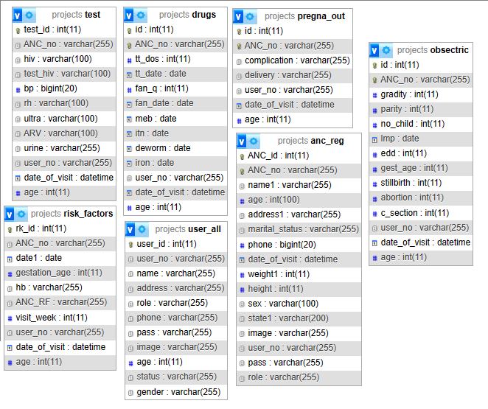

Figure 3.4: Database Entity Relationship Diagram

## 3.6.5 Input and Output Design

**LOGIN INTERFACE**

Enter Username

Enter Password

**Login**

Figure 3.5: Login Interface

Enter full Name

Enter weight

Enter height

Gender

Marital status

**REGISTRATION FORM**

Enter phone number

Address

State of Origin

LGA of Origin

Passport

**CANCEL**

**SAVE**

Figure 3.6: Registration Form

WEEK OPTION

**RISK FACTOR FORM**

PATIENT ID

DATE

AGE

GESTATION AGE (Weeks)

HB

Risk Factor

**SAVE**

**CANCEL**

Figure 3.7: Risk Factor Form

**OBSTETRIC HISTORY FORM**

STILL BIRTH

ABORTION

CAESARIAN SECTION (in weeks)

AGE

PATIENT ID

GRAVITY

NO. OF CHILDREN

PARITY

LMP

GESTATION (in weeks)

**SAVE**

Figure 3.8: Obstetric History Form

**DRUGS AND SERVICES FORM**

PATIENT ID

Tetanus toxoid (TT) dose

Fansider dose

Date

Mebend date

Deworming date

**SAVE**

Iron folates dose

ITN Date

AGE

Figure 3.9: Drugs and Service Form

## 3.7 System Requirements Specification

## 3.7.1 Hardware Requirements

The software designed needed the following hardware for an effective operation of the newly designed system.

1. A system running on intel, P(R) duo core with higher processor
2. The-Random Access Memory (RAM) should be at least 512mb.
3. Enhanced keyboard.
4. At least 20-GB hard disk.
5. V.G.A or a colored monitor.

## 3.7.2 Software Requirements

The software requirements include:

1. A window 7 or higher version of operating system.
2. XAMP or WAMP for Database
3. PHP

## 3.7.3 Personnel Requirements

Any computer literate who has a technical knowhow of internet surfing can use the system because it is user friendly.

# CHAPTER FOUR

# RESULTS AND DISCUSSION

## 4.1 Introduction

The new system is designed using PHP and MySQL programming language for easy records inserting and updating. This system will help in managing and easily retrieving of information from the system for management purposes. The new system Antenatal Information system.

## 4.2 Results

**4.2.1 Welcome Interface**

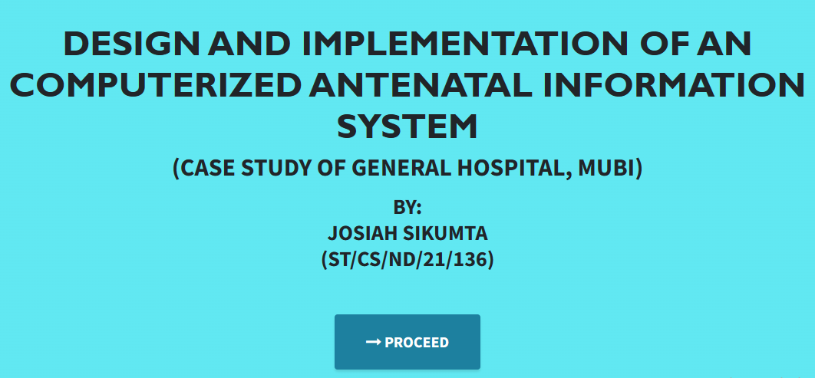

Figure 4.1: Welcome Interface

The above figure 4.1 shows the welcome page of the antenatal information system, on the welcome page is the first page that displays the project topic.

**4.2.2 Login Interface**

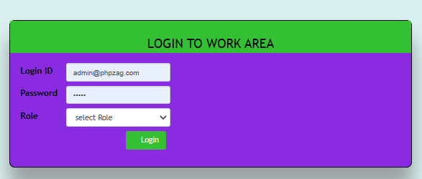

Figure 4.2: Login page interface

Figure 4.2 the login interface allows the Patient, Doctors and Administrator to enter his username and password to get access to the system.

**4.2.3 Register Patient**

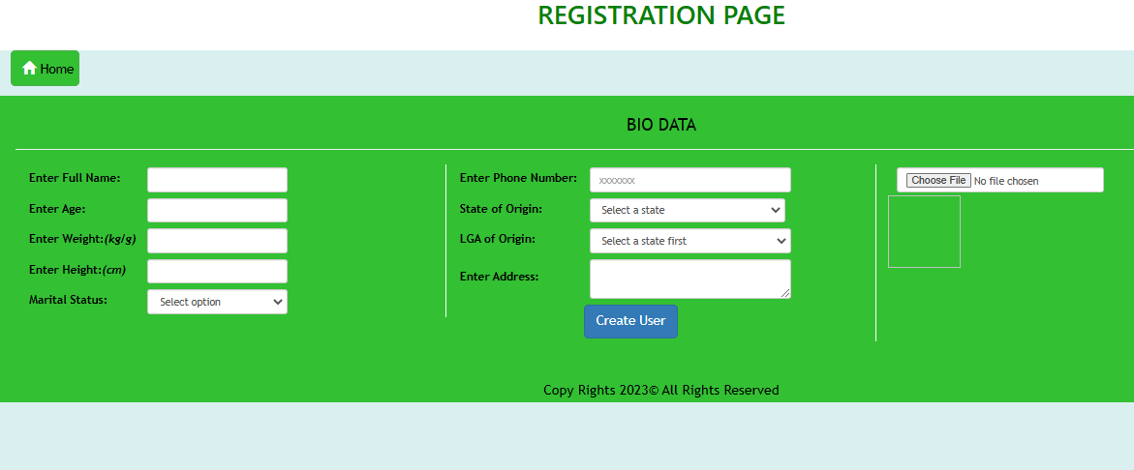

Figure 4.3: Registration Interface

Figure 4.2.3 above shows where the admin will register new patients by filling in their information.

**4.2.4 Risk Factor interface**

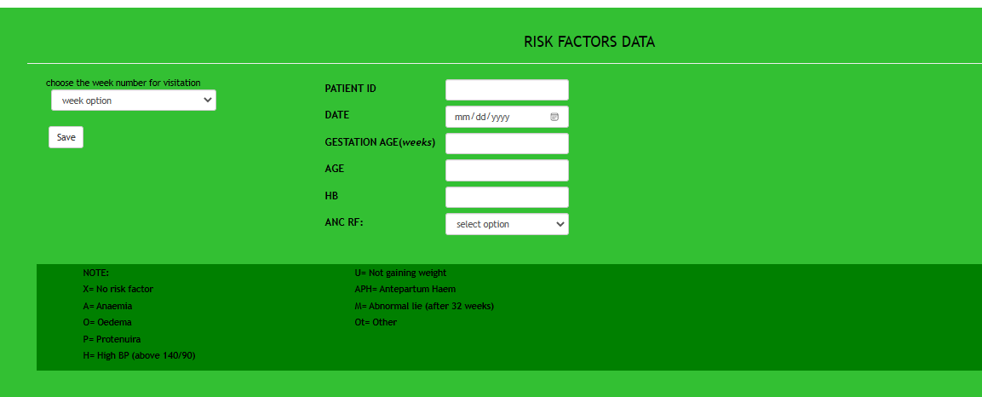

Figure 4.4: Risk Factor Interface

Figure 4.4 is this section is used to add patients risk factor into the system.

**4.2.5 Obstetric History**

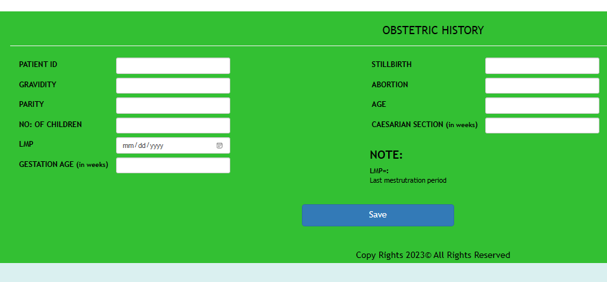

Figure 4.5: Obstetric History Interface

Figure 4.5 above is used to add obstetric history of the patient.

**4.2.6 Tested Data**

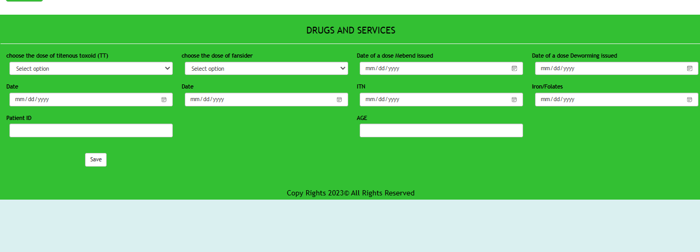

Figure 4.6: Tested Data

Figure 4.2.6 above is showing a payment receipt after successful payment has been made.

**4.2.7 Pregnancy Outcome**

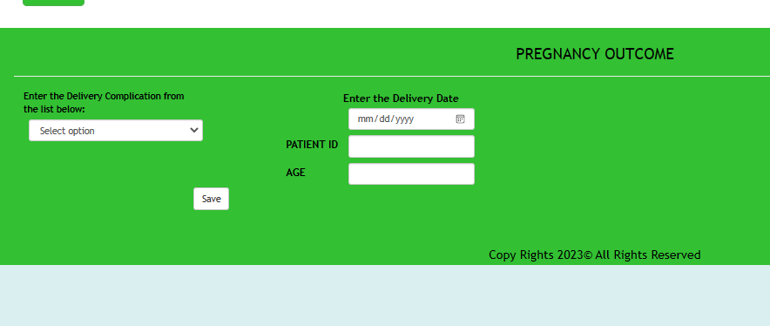

Figure 4.7: Pregnancy Outcome

## 4.3 Discussion

Welcome Interface: The Welcome Interface serves as the initial point of interaction for users when they access the Computerized Antenatal Information System. It typically includes a welcoming message and provides an overview of the system's capabilities. Users are usually presented with options to navigate further into the system, such as logging in or accessing specific functionalities.

Login Interface: The Login Interface is where authorized users provide their credentials to access the system securely. It typically includes fields for entering usernames and passwords. Additional features such as password recovery or account creation may be present.

Register Patient Interface: The Register Patient Interface allows healthcare providers to input and maintain patient information for antenatal care. It typically includes fields for capturing details such as patient names, contact information, medical history, and identification data. This interface ensures accurate and organized patient records.

Risk Factor Interface: The Risk Factor Interface is used to record and assess risk factors associated with a patient's pregnancy. Healthcare providers can enter information about medical conditions, lifestyle factors, or other variables that may influence the course of the pregnancy. This helps in identifying potential complications and tailoring care accordingly.

Obstetric History Interface: The Obstetric History Interface is designed to collect and store a patient's past obstetric history, including previous pregnancies, deliveries, and any related complications. This information is crucial for assessing the patient's current pregnancy and planning appropriate care.

Tested Data Interface: The Tested Data Interface records the results of medical tests and diagnostic procedures performed during the antenatal period. It includes fields for test names, dates, and results, allowing healthcare providers to track the patient's health and monitor any abnormalities.

Pregnancy Outcome Interface: The Pregnancy Outcome Interface documents the final outcome of the pregnancy, including details on the delivery, complications, and the health status of the newborn. This interface is essential for maintaining a comprehensive patient history and ensuring continuity of care.

Collectively, these interfaces form the core components of the Computerized Antenatal Information System. They are designed to enhance the efficiency of antenatal care processes, improve patient record-keeping, and facilitate informed decision-making by healthcare providers at General Hospital, Mubi.

## 4.4 User manual

The following are the necessary steps to take in order to use the system efficiently and effectively.

1. Load the url of the system <https://localhost/antenatal/> the welcome page will be displayed.
2. Click on the **Proceed** button to proceed to the main system.
3. If you created an account, provide your login details by entering your username and password.
4. Depending on the login details provided you will be automatically directed to the dashboard.
5. The various task that you can perform on the portal will be displayed on the sidebar of the dashboard.

# CHAPTER FIVE

# SUMMARY, CONCLUSION AND RECOMMENDATIONS

## 5.1 Summary

In summary, the "Design and Implementation of a Computerized Antenatal Information System" represents a significant advancement in healthcare administration, particularly within the context of antenatal care at General Hospital, Mubi. This system has been meticulously designed and implemented to streamline and optimize the management of antenatal patient information, improving efficiency, data accuracy, and overall patient care.

The Computerized Antenatal Information System provides a user-friendly platform for healthcare providers to register patients, assess risk factors, record obstetric history, and monitor test results throughout the antenatal period. The successful implementation of this system underscores the transformative potential of technology in healthcare administration, fostering improved patient outcomes and streamlined administrative operations.

## 5.2 Conclusion

The design and implementation of the Computerized Antenatal Information System have yielded concrete benefits for General Hospital, Mubi. This project demonstrates how technology can be harnessed to enhance the quality of healthcare administration, particularly in the domain of antenatal care. By automating data collection, risk assessment, and test result tracking, the system has improved patient care coordination and data accuracy, leading to enhanced patient outcomes.

The successful implementation of this system stands as a testament to the power of technology in healthcare, offering a model for other healthcare institutions seeking to modernize their patient information management processes.

**5.3 Recommendations**

Based on the successful implementation of the Computerized Antenatal Information System, several recommendations can be made for its continued improvement and broader adoption:

1. User Training: Provide comprehensive training to healthcare providers and staff to ensure efficient utilization of the system.
2. Data Integration: Explore opportunities to integrate the system with electronic health records (EHR) and other healthcare systems for a more comprehensive patient information ecosystem.
3. Telemedicine Integration: Consider integrating telemedicine capabilities to enable remote consultations and enhance patient care accessibility.
4. Continuous Updates: Regularly update and maintain the system to incorporate new medical guidelines, data security measures, and user feedback.

## 5.4 Contribution to Knowledge

This project contributes to knowledge in several key areas:

Healthcare Technology: It exemplifies how technology can significantly improve administrative processes within healthcare institutions, leading to enhanced patient care coordination.

Data Accuracy: The system emphasizes the importance of accurate and comprehensive patient information in healthcare decision-making.

## 5.5 Area for Further Work

Future work in this area could include:

Mobile Application: Developing a mobile application version of the system to facilitate data entry and access for healthcare providers in remote or mobile settings.

Data Analytics: Exploring advanced analytics to extract insights from patient data and predict potential complications.

Security Enhancements: Continuously monitoring and enhancing data security measures to safeguard patient information and comply with data protection regulations.

Integration with External Systems: Expanding integration capabilities with external healthcare systems, laboratories, and pharmacies to improve patient care coordination.

**References**

AppFolio. (2021). 2021 Multifamily Predictions Report. Retrieved from <https://www.appfolio.com/blog/2021-multifamily-predictions-report>

Avail. (2021). The 2021 Landlord and Tenant Rental Market Report. Retrieved from <https://www.avail.co/education/guides/2021-landlord-and-tenant-rental-market-report>

Babatunde, S., Iliya, S., Sanni, R., & Ogwueleka, F. (2021). Cloud Computing Adoption for Property Management Systems in the Real Estate Industry. Journal of Systems and Information Technology, 23(2), 289-308.

Bari, A. A., Zhang, Y., Yaseen, A., & Hwang, I. (2022). A Review of Data Analytics in Property Management. In 2022 5th International Conference on Control, Automation and Robotics (ICCAR), 715-719.

Buildium. (2021). 2021 State of the Property Management Industry Report. Retrieved from <https://www.buildium.com/resources/industry-reports/property-management-industry-report/>

Chen, J., & Huang, Z. (2021). Cloud-Based Property Management System with Mobile Integration for Small and Medium-Sized Landlords. Journal of Systems and Information Technology, 23(3), 486-503.

Daas, A., Messalem, R., Schäfer, J., & Steinmetz, R. (2021). Design and Development of Mobile Applications for Property Management. International Journal of Information Systems and Project Management, 9(2), 5-19.

Elmasri, R., & Navathe, S. B. (2019). Fundamentals of Database Systems. Pearson, New York.

Filho, H. R. S., Grillo, M. C. C., Oliveira, T. V. B., Santana, L. H., & Rodrigues, G. O. (2021). An Artificial Intelligence Platform for Property Management: A Conceptual Model. Computers in Industry, 125, 103-379.

Ghazal, A., Giceva, J., Idreos, S., & Pölitz, C. (2020). NoSQL and SQL Data Models: A Systematic Mapping Study. ACM Computing Surveys, 53(2), 1-38.

Ghosh, S., Rahman, M. M., Rana, N. P., Dwivedi, Y. K., & Talukder, S. (2021). The Role of Artificial Intelligence and Machine Learning in Real Estate: A Comprehensive Literature Review. Information Technology & People, 1-41.

Jagero, N., & Kangethe, S. (2020). Evaluation of Records Management Systems in Public Universities in Kenya. International Journal of Information Systems and Project Management, 8(3), 43-62.

Khan, M. I., & Al Ameen, M. (2021). The Adoption of Property Management Systems in the Real Estate Sector. Journal of Business and Management, 23(2), 71-92.

Kwon, I., & Lee, H. (2020). The Role of Management Information Systems in Data Analytics: A Strategic Perspective on Global Business Environments. Information Systems Frontiers, 22(4), 909-924.

Lee, S., Shin, J., & Jeong, J. (2020). Web-based Rental Property Management System for Efficient and Effective Property Management. Journal of Engineering Technology, 18(1), 221-229.

Letchkov, N., Koychev, I., & Ivanov, B. (2022). Cloud-Based Property Management Systems. In Proceedings of the International Conference on Advances in Business, Management and Law (pp. 169-177). Springer.

Liu, J., Cao, J., Zhang, J., & Xie, Y. (2021). Design and Implementation of Cloud-Based Record Management System for Universities. Security and Communication Networks, 2021, 665-883.

Mathe, N., Krotzsch, S., Lacroix, Z., & Lutters, W. (2021). Artificial Intelligence for Records Management: A Research Agenda. In Proceedings of the 54th Hawaii International Conference on System Sciences.

Motahari-Nezhad, H. R., Stephenson, B., Shahbazian, M., & Foster, H. (2021). Database Management Systems. In Handbook on Securing Cyber-Physical Critical Infrastructure (pp. 195-217). Springer.

NMHC. (2021). NMHC Rent Payment Tracker Finds 79.4 Percent of Apartment Households Paid Rent as of June 6. Retrieved from <https://www.nmhc.org/news/press-releases/nmhc-rent-payment-tracker-finds-79-4-percent-of-apartment-households-paid-rent-as-of-june-6/>

Oliveira, T., & Martins, M. F. (2021). The Role of Management Information Systems in Decision-Making and Communication Processes. Telematics and Informatics, 57, 101-554.

Osman, S., Al-Nabhan, N., Elhajj, I., & Chehab, A. (2020). Internet of Things for Real Estate Property Management: A Comprehensive Survey. Journal of Network and Computer Applications, 163, 102632

Oussaid, R., Khefifi, H., & Amghar, Y. (2021). Agile Methodologies in Property Management Systems: A Systematic Review. International Journal of Software Engineering and Computer Systems, 1(1), 24-33.

Rahman, M. M., Azam, M. N. H., & Sazzad, M. K. (2020). An Integrated Framework for E-Records Management System (ERMS) Development: A Study on Bangladesh Government Sector. International Journal of Electronic Government Research, 16(3), 19-38.

Ramakrishnan, R., & Gehrke, J. (2020). Database Management Systems. McGraw-Hill.

Rizvi, S., Khan, M. A., Bhatti, R. A., & Ziauddin, Z. (2021). A Comparative Study of Database Management Systems. Journal of Information Systems and Technology Management, 18, 202-1134.

Sarker, S., & Ali, A. S. (2020). Agile Software Development for Real Estate Management Systems: A Systematic Review. IEEE Access, 8, 21205-21220.

Shen, Y., He, X., & Fan, W. (2021). Mobile Property Management Systems: A Study of Design and Implementation. Information Systems Frontiers, 1-14.

Singhal, P., Sharma, S., & Srinivasan, A. (2021). Record Management System: A Boon for Organizational Efficiency. In International Conference on Information Management and Machine Intelligence (pp. 29-38). Springer.

Statista. (2021). Property Management Software Market Size Worldwide from 2019 to 2025. Retrieved from <https://www.statista.com/statistics/1174703/property-management-software-market-size-worldwide/>

Turban, E., Sharda, R., & Delen, D. (2021). Business Intelligence and Analytics: Systems for Decision Support. Pearson Education.

Wu, S., & Zhu, X. (2021). An Empirical Study of the Application of Management Information Systems in Organizations. Journal of Systems Science and Information, 9(1), 98-109.

Yang, S., Zuo, M., & Hu, Q. (2020). A Framework for Smart Rental Property Management. IEEE Access, 8, 134127-134139.

Yau, T. W., Yiu, K. T., & Leung, S. W. (2021). Enhancing the Tenant-Management Communication Process through Mobile Technology in Residential Property Management. Journal of Real Estate Research, 43(1), 49-78.

Zhang, J., Li, S., Yang, W., & Wang, X. (2020). Big Data Analytics in Property Management: A Review. Smart Cities, 3(4), 974-991.

Zillow. (2021). Zillow Group Consumer Housing Trends Report 2021. Retrieved from <https://www.zillow.com/report/2021/consumer-housing-trends/>

**References**

Bhattarai, M., Van Teijlingen, E., Simkhada, P., & Williams, J. S. (2022). Security Features of Computerized Antenatal Health Information Systems: A Comprehensive Review. Health Informatics Journal, 28(1), 14604582211063326.

D'Souza, R., Van der Gijp, A., Yadav, P., & George, T. (2021). Decision Support System for Antenatal Care: Development and Evaluation of a Computerized Model. JMIR Medical Informatics, 9(1), e25014.

Kumar, A., Khan, A. M., & Akuhwa, T. R. (2022). Mobile-Based Antenatal Care: A Pilot Project for Improving Maternal Health in Underserved Areas. Frontiers in Public Health, 10, 828.

Nyanchoka, L., Tudur-Smith, C., Thu, M., & Paul, M. (2020). Use of Computerized Antenatal Care Algorithms for Decision Support: A Systematic Review. BMJ Global Health, 5(1), e002394.

Smith, S. (2020). Usability Evaluation of Health Information Systems: A Systematic Review. Perspectives in Health Information Management, 17(Fall), 1c.

Warth, L. L., Agyepong, I. A., & Kanmiki, E. W. (2019). Implementation of a Computerized Health Management Information System to Improve Data Quality and Outcomes: A Case Study from Ghana. Journal of Medical Internet Research, 21(12), e14142.

World Health Organization (WHO). (2016). WHO recommendations on antenatal care for a positive pregnancy experience. Retrieved from <https://www.who.int/reproductivehealth/publications/maternal_perinatal_health/anc-positive-pregnancy-experience/en/>

**APPENDIX A**

**Welcome Interface**



**Login Interface**



**Register Patient**



**Risk Factor interface**



**Obstetric History**



**Tested Data**



**Pregnancy Outcome**



# APPENDIX B

**PROGRAM CODE**

<!DOCTYPE html>

<html lang="en" class="" style="height: auto;">

<head>

<style>

:root{

--base_url:http://localhost/childAbuse/cdcms/;

}

</style>

<meta charset="utf-8">

<meta name="viewport" content="width=device-width, initial-scale=1">

<title>Child Abuse Management Information System</title>

<link rel="icon" href="http://localhost/childAbuse/cdcms/uploads/logo-1693990617.png" />

<!-- Google Font: Source Sans Pro -->

<!-- <link rel="stylesheet" href="https://fonts.googleapis.com/css?family=Source+Sans+Pro:300,400,400i,700&amp;display=fallback"> -->

<!-- Font Awesome -->

<link rel="stylesheet" href="http://localhost/childAbuse/cdcms/plugins/fontawesome-free/css/all.min.css">

<!-- Ionicons -->

<!-- <link rel="stylesheet" href="https://code.ionicframework.com/ionicons/2.0.1/css/ionicons.min.css"> -->

<!-- Tempusdominus Bootstrap 4 -->

<link rel="stylesheet" href="http://localhost/childAbuse/cdcms/plugins/tempusdominus-bootstrap-4/css/tempusdominus-bootstrap-4.min.css">

<!-- DataTables -->

<link rel="stylesheet" href="http://localhost/childAbuse/cdcms/plugins/datatables-bs4/css/dataTables.bootstrap4.min.css">

<link rel="stylesheet" href="http://localhost/childAbuse/cdcms/plugins/datatables-responsive/css/responsive.bootstrap4.min.css">

<link rel="stylesheet" href="http://localhost/childAbuse/cdcms/plugins/datatables-buttons/css/buttons.bootstrap4.min.css">

<!-- Select2 -->

<link rel="stylesheet" href="http://localhost/childAbuse/cdcms/plugins/select2/css/select2.min.css">

<link rel="stylesheet" href="http://localhost/childAbuse/cdcms/plugins/select2-bootstrap4-theme/select2-bootstrap4.min.css">

<!-- iCheck -->

<link rel="stylesheet" href="http://localhost/childAbuse/cdcms/plugins/icheck-bootstrap/icheck-bootstrap.min.css">

<!-- JQVMap -->

<link rel="stylesheet" href="http://localhost/childAbuse/cdcms/plugins/jqvmap/jqvmap.min.css">

<!-- Theme style -->

<link rel="stylesheet" href="http://localhost/childAbuse/cdcms/dist/css/adminlte.css">

<link rel="stylesheet" href="http://localhost/childAbuse/cdcms/dist/css/custom.css">

<!-- overlayScrollbars -->

<link rel="stylesheet" href="http://localhost/childAbuse/cdcms/plugins/overlayScrollbars/css/OverlayScrollbars.min.css">

<!-- Daterange picker -->

<link rel="stylesheet" href="http://localhost/childAbuse/cdcms/plugins/daterangepicker/daterangepicker.css">

<!-- summernote -->

<link rel="stylesheet" href="http://localhost/childAbuse/cdcms/plugins/summernote/summernote-bs4.min.css">

<!-- SweetAlert2 -->

<link rel="stylesheet" href="http://localhost/childAbuse/cdcms/plugins/sweetalert2-theme-bootstrap-4/bootstrap-4.min.css">

<style type="text/css">/* Chart.js */

@keyframes chartjs-render-animation{from{opacity:.99}to{opacity:1}}.chartjs-render-monitor{animation:chartjs-render-animation 1ms}.chartjs-size-monitor,.chartjs-size-monitor-expand,.chartjs-size-monitor-shrink{position:absolute;direction:ltr;left:0;top:0;right:0;bottom:0;overflow:hidden;pointer-events:none;visibility:hidden;z-index:-1}.chartjs-size-monitor-expand>div{position:absolute;width:1000000px;height:1000000px;left:0;top:0}.chartjs-size-monitor-shrink>div{position:absolute;width:200%;height:200%;left:0;top:0}

</style>

<!-- jQuery -->

<script src="http://localhost/childAbuse/cdcms/plugins/jquery/jquery.min.js"></script>

<!-- jQuery UI 1.11.4 -->

<script src="http://localhost/childAbuse/cdcms/plugins/jquery-ui/jquery-ui.min.js"></script>

<!-- SweetAlert2 -->

<script src="http://localhost/childAbuse/cdcms/plugins/sweetalert2/sweetalert2.min.js"></script>

<!-- Toastr -->

<script src="http://localhost/childAbuse/cdcms/plugins/toastr/toastr.min.js"></script>

<script>

var _base_url_ = 'http://localhost/childAbuse/cdcms/';

</script>

<script src="http://localhost/childAbuse/cdcms/dist/js/script.js"></script>

</head> <body class="sidebar-mini layout-fixed control-sidebar-slide-open layout-navbar-fixed sidebar-mini-md sidebar-mini-xs" data-new-gr-c-s-check-loaded="14.991.0" data-gr-ext-installed="" style="height: auto;">

<div class="wrapper">

$('#find-transaction [name="tracking_code"]').focus();

})

uni_modal("Enter Tracking Number","transaction/find_transaction.php");

})

})

</script>

<!-- Content Wrapper. Contains page content -->

<div class="content-wrapper pt-3" style="min-height: 567.854px;">

<!-- Main content -->

<section class="content ">

<div class="container-fluid">

<style>

img#cimg{

height: 15vh;

width: 15vh;

object-fit: scale-down;

border-radius: 100% 100%;

}

img#cimg2{

height: 50vh;

width: 100%;

object-fit: contain;

/* border-radius: 100% 100%; */

}

</style>

<div class="col-lg-12">

<div class="card card-outline card-primary">

<div class="card-header">

<h5 class="card-title">System Information</h5>

<!-- <div class="card-tools">

<a class="btn btn-block btn-sm btn-default btn-flat border-primary new_department" href="javascript:void(0)"><i class="fa fa-plus"></i> Add New</a>

</div> -->

</div>

<div class="card-body">

<form action="" id="system-frm">

<div id="msg" class="form-group"></div>

<div class="form-group">

<label for="name" class="control-label">System Name</label>

<input type="text" class="form-control form-control-sm" name="name" id="name" value="Child Abuse Management Information System">

</div>

<div class="form-group">

<label for="short_name" class="control-label">System Short Name</label>

<input type="text" class="form-control form-control-sm" name="short_name" id="short_name" value="CAMIS- PHP">

</div>

<div class="form-group">

<label for="content[about_us]" class="control-label">Welcome Content</label>

<textarea type="text" class="form-control form-control-sm summernote" name="content[welcome]" id="welcome"><p style="margin-right: 0px; margin-bottom: 15px; margin-left: 0px; padding: 0px;"><img

div></div></div></form></div></textarea>

</div>

<div class="form-group">

<label for="" class="control-label">System Logo</label>

<div class="custom-file">

<input type="file" class="custom-file-input rounded-circle" id="customFile" name="img" onchange="displayImg(this,$(this))">

<label class="custom-file-label" for="customFile">Choose file</label>

</div>

</div>

<div class="form-group d-flex justify-content-center">

<img src="http://localhost/childAbuse/cdcms/uploads/logo-1693990617.png" alt="" id="cimg" class="img-fluid img-thumbnail">

</div>

<div class="form-group">

<label for="" class="control-label">Cover</label>

<div class="custom-file">

<input type="file" class="custom-file-input rounded-circle" id="customFile" name="cover" onchange="displayImg2(this,$(this))">

<label class="custom-file-label" for="customFile">Choose file</label>

</div>

</div>

<div class="form-group d-flex justify-content-center">

<img src="http://localhost/childAbuse/cdcms/uploads/cover-1693997789.png" alt="" id="cimg2" class="img-fluid img-thumbnail bg-gradient-dark border-dark">

</div>

<fieldset>

<legend>Child Care's Information</legend>

<div class="form-group">

<label for="email" class="control-label">Email</label>

<input type="email" class="form-control form-control-sm" name="email" id="email" value="info@kponkius.com">

</div>

<div class="form-group">

<label for="contact" class="control-label">Contact #</label>

<input type="text" class="form-control form-control-sm" name="contact" id="contact" value="">

</div>

<div class="form-group">

<label for="address" class="control-label">Address</label>

<textarea rows="3" class="form-control form-control-sm" name="address" id="address" style="resize:none">Federal Polytechnic, Mubi</textarea>

</div>

</fieldset>

</form>

</div>

<div class="card-footer">

<div class="col-md-12">

<div class="row">

<button class="btn btn-sm btn-primary" form="system-frm">Update</button>

</div>

</div>

</div>

</div>

</div>

<script>

function displayImg(input,_this) {

if (input.files && input.files[0]) {

var reader = new FileReader();

reader.onload = function (e) {

$('#cimg').attr('src', e.target.result);

_this.siblings('.custom-file-label').html(input.files[0].name)

}

reader.readAsDataURL(input.files[0]);

}

}

function displayImg2(input,_this) {

if (input.files && input.files[0]) {

var reader = new FileReader();

reader.onload = function (e) {

_this.siblings('.custom-file-label').html(input.files[0].name)

$('#cimg2').attr('src', e.target.result);

}

reader.readAsDataURL(input.files[0]);

}

}

function displayImg3(input,_this) {

if (input.files && input.files[0]) {

var reader = new FileReader();

reader.onload = function (e) {

_this.siblings('.custom-file-label').html(input.files[0].name)

$('#cimg3').attr('src', e.target.result);

}

reader.readAsDataURL(input.files[0]);

}

}

$(document).ready(function(){

$('.summernote').summernote({

height: 200,

toolbar: [

[ 'style', [ 'style' ] ],

[ 'font', [ 'bold', 'italic', 'underline', 'strikethrough', 'superscript', 'subscript', 'clear'] ],

[ 'fontname', [ 'fontname' ] ],

[ 'fontsize', [ 'fontsize' ] ],

[ 'color', [ 'color' ] ],

[ 'para', [ 'ol', 'ul', 'paragraph', 'height' ] ],

[ 'table', [ 'table' ] ],

['insert', ['link', 'picture']],

[ 'view', [ 'undo', 'redo', 'fullscreen', 'codeview', 'help' ] ]

]

})

})

</script> </div>

</section>

<!-- /.content -->

<div class="modal fade" id="confirm_modal" role='dialog'>

<div class="modal-dialog modal-md modal-dialog-centered" role="document">

<div class="modal-content">

<div class="modal-header">

<h5 class="modal-title">Confirmation</h5>

</div>

<div class="modal-body">

<div id="delete_content"></div>

</div>

<div class="modal-footer">

<button type="button" class="btn btn-primary btn-flat" id='confirm' onclick="">Continue</button>

<button type="button" class="btn btn-secondary btn-flat" data-dismiss="modal">Close</button>

</div>

</div>

</div>

</div>

<div class="modal fade" id="uni_modal" role='dialog'>

<div class="modal-dialog modal-md modal-dialog-centered" role="document">

<div class="modal-content">

<div class="modal-header">

<h5 class="modal-title"></h5>

</div>

<div class="modal-body">

</div>

<div class="modal-footer">

<button type="button" class="btn btn-primary btn-flat" id='submit' onclick="$('#uni_modal form').submit()">Save</button>

<button type="button" class="btn btn-secondary btn-flat" data-dismiss="modal">Cancel</button>

</div>

</div>

</div>

</div>

<div class="modal fade" id="uni_modal_right" role='dialog'>

<div class="modal-dialog modal-full-height modal-md" role="document">

<div class="modal-content">

<div class="modal-header">

<h5 class="modal-title"></h5>

<button type="button" class="close" data-dismiss="modal" aria-label="Close">

<span class="fa fa-arrow-right"></span>

</button>

</div>

<div class="modal-body">

</div>

</div>

</div>

</div>

<div class="modal fade" id="viewer_modal" role='dialog'>

<div class="modal-dialog modal-md" role="document">

<div class="modal-content">

<button type="button" class="btn-close" data-dismiss="modal"><span class="fa fa-times"></span></button>

<img src="" alt="">

</div>

</div>

</div>

</div>

<!-- /.content-wrapper -->

<script>

$(document).ready(function(){

window.viewer_modal = function($src = ''){

start_loader()

var t = $src.split('.')

t = t[1]

if(t =='mp4'){

var view = $("<video src='"+$src+"' controls autoplay></video>")

}else{

var view = $("<img src='"+$src+"' />")

}

$('#viewer_modal .modal-content video,#viewer_modal .modal-content img').remove()

$('#viewer_modal .modal-content').append(view)

$('#viewer_modal').modal({

show:true,

backdrop:'static',

keyboard:false,

focus:true

})

end_loader()

}